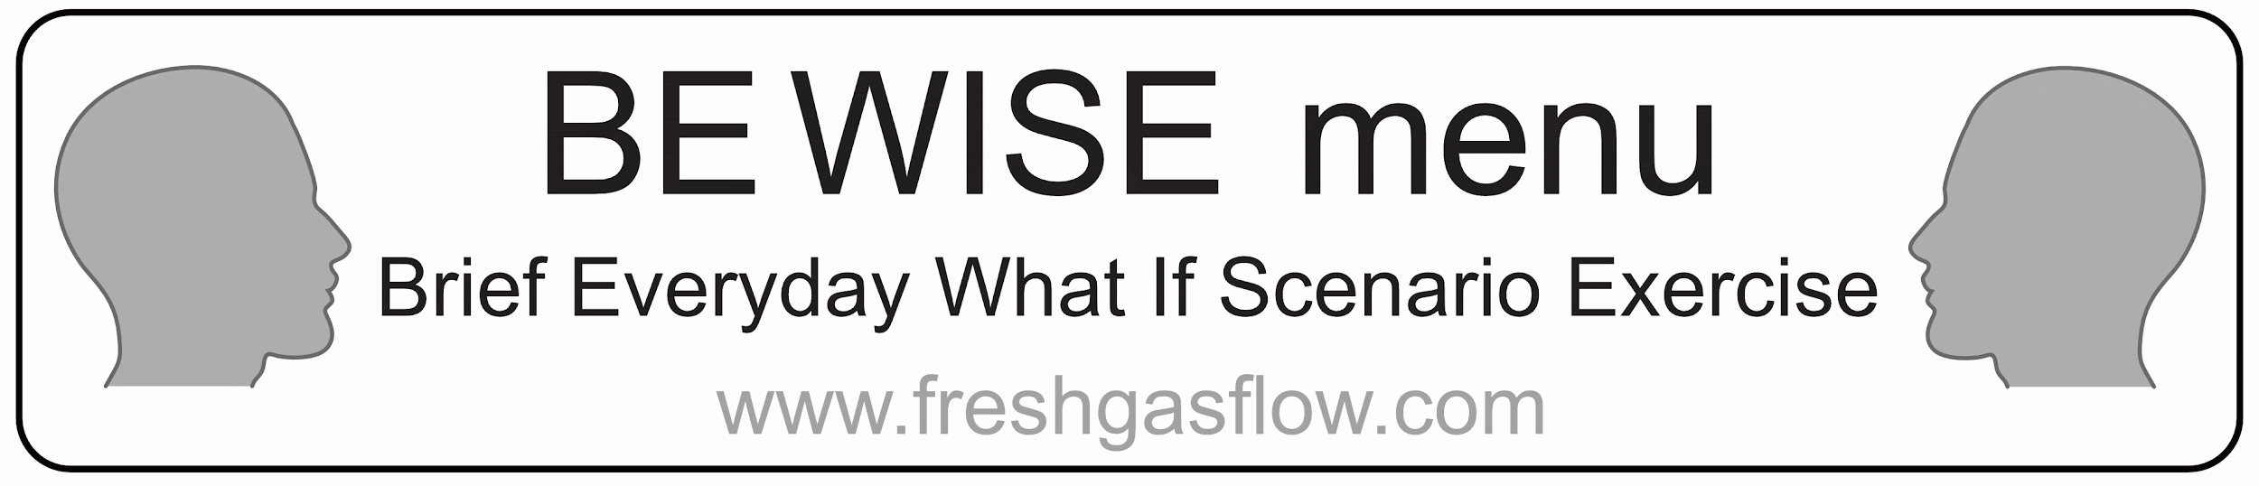
Note: This is only a sample menu. Edit to make it suitable for your hospital

- Acute Coronary Syndromes
- Adult Basic Life support
- Adult Advanced life support: VF/VT
- Adult Advanced life support: Asystole /PEA
- Anaphylaxis
- Atrial fibrillation needing urgent treatment
- Brady arrhythmias
  - include how to do emergency pacing
- Bronchospasm
- Difficult airway
  - include difficult airway trolley location & how to do front-of-neck access
- Embolism (air/clot)
- Fire drill
- Gas supply failure
- Laryngospasm
- Laser airway fire
- Local anaesthetic toxicity
- Major haemorrhage (general, obstetric)
- Malignant hyperthermia
  - Where is the dantrolene kept
- Power failure
- Supra ventricular tachycardia (narrow complex tachycardia)
- Tension Pneumothorax
- Total spinal

